What skills the market is looking for?

The objective of this extension to Torre.co is to do a check over what skills are the companies looking for and how may jobs opportunities have been opened on each user skill.

User journery

1. User load home screen
Events generated:
- SHOW_HOME
- SELECT_LOGIN_BUTTON
- FOUND_PROFILE
- NOT_FOUND_PROFILE

2. Jobs fit screen
Events generated:
- SHOW_JOBS_FIT_SCREEN
- SCROLL_DOWN_SCREEN
- SCROLL_UP_SCREEN
- SELECT_SKILL

Completed work:
- AWS CodePipeline defined for Frontend and Backend projects.
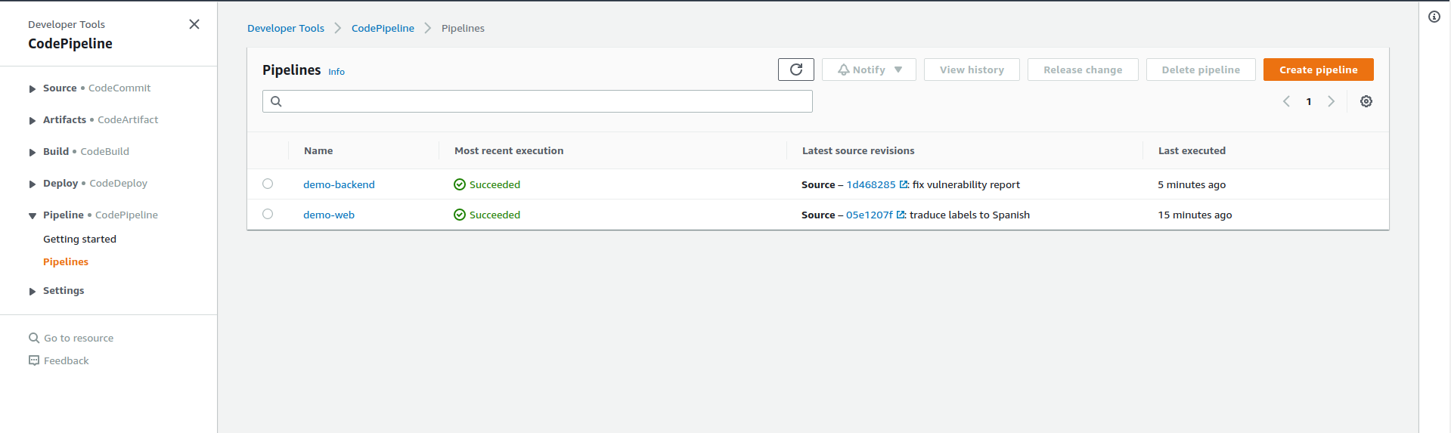
- Sonar Cloud defined for Frontend and Backend Projects:
Backend project:
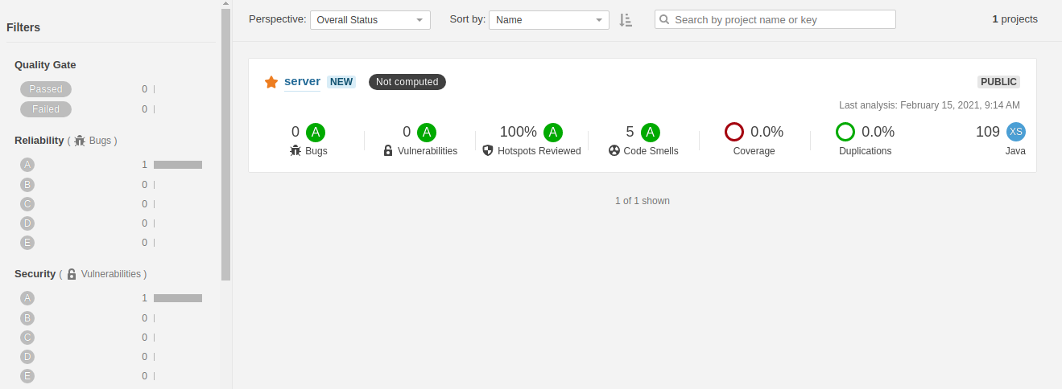
Frontend project:
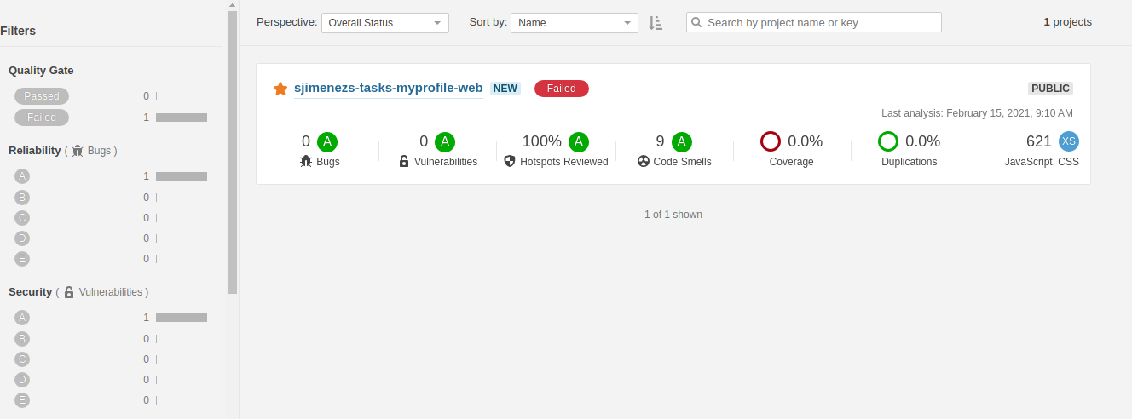
- AWS ECS Cluster for Backend Deployment
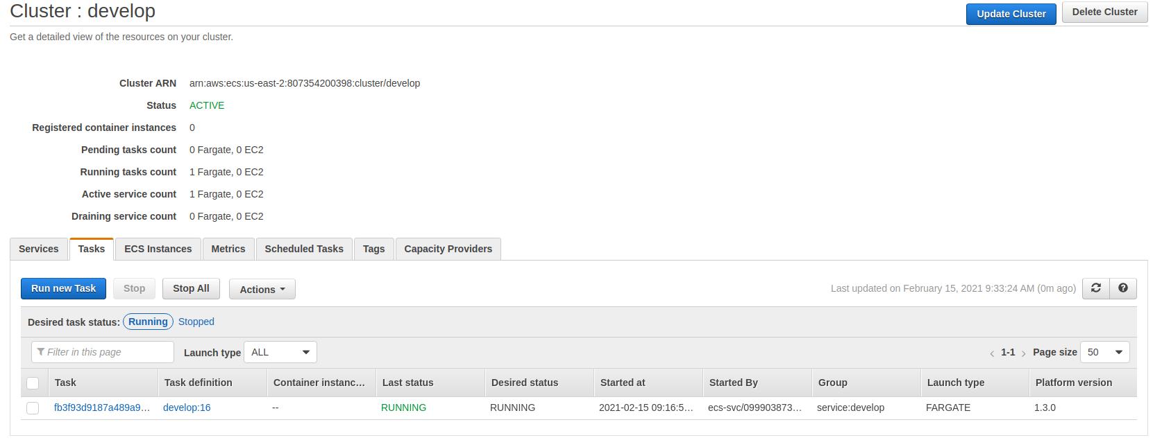
- Home screen development
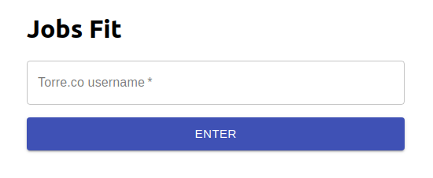
- Jobs-skill fit screen
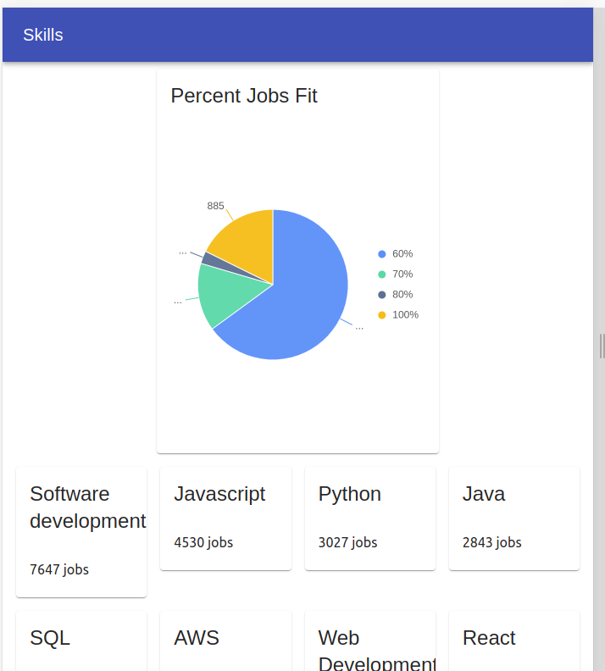
- Backend services for sync data from Torre.co and expose services to frontend.
- Continous delivery including database changes supported on Liquibase.

Future work:
- To pay technical issues reported by Sonar.
- To code unit test for backend.
- To code end to end test with automatic deployment for test.
- To add trace logs: LogsDNA
- To setup APM NewRelic
- To send Events to Amplitude

